Yaroslav the Wise Novgorod State University
St. Petersburg Institute of History , Russian Academy of Sciences
Institute of Archeology, Russian Academy of Sciences

Center for the Studies of History of the Baltic Region and North-West Russia

CALL FOR PARTICIPATION
International Conference
The Hansa Phenomenon: the Hanseatic Communicative Space

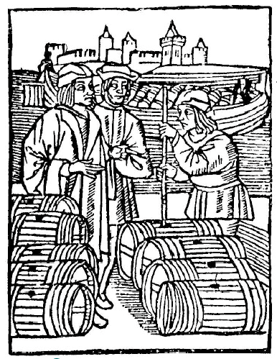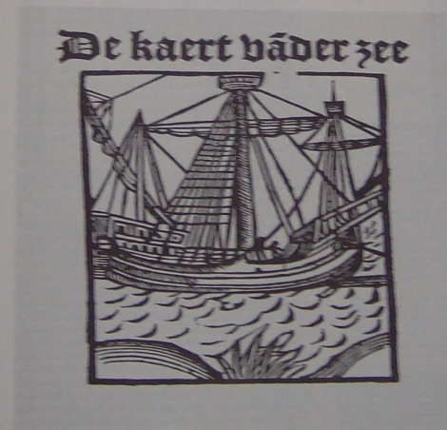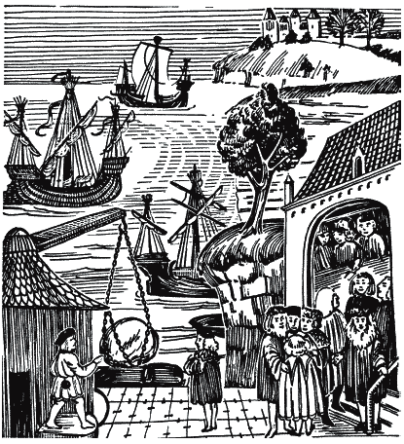

May, 20-21, 2019
Veliky Novgorod (Russia) Novgorod State University
A broad exchange of views on the typological features and dynamics of the development of the internal organization of the Hanseatic Union and its contacts with the states of the Baltic region and Russia in the Middle Ages and Early Modern Times is planned to take place during the conference. As the main task, the organizing committee intends to propose a discussion of the problem of variability and transformation of the internal and international relations of Hansa, considered through the prism of the historical realities of the Hanseatic communicative space.
Problems to discuss:
- Hanseatic space as a communicative environment
- ways of internal integration processes
- mechanisms of Hanseatic trade and their transformation
- legal framework for international trade cooperation
- phenomenon of trade expansion
- role of small towns and villages in the development of Hanseatic trade
- forms of information exchange
- educational and cultural exchange as a result of the interaction of Hansa partners
- Hanseatic archeology

- On-line participation is acceptable
- Papers of the participants will be published. Conference organizers reserve the right to select materials for publication.
- Guest participants are provided accommodation and meals.
During the days of the conference we plan to organize presentations, discussions, master classes of Russian and foreign experts. It is planned to prepare an exposition of archaeological finds of the Archaeological Center of NovSU related to Hansa – Novgorod contacts and an exposition of books and publications on the topic of the conference.
Participants will have a chance to visit ancient Novgorod Kremlin, Yaroslav Court Yard, Rurik Settlement (Gorodischche) and to make a field trip to the archaeological excavation site.
Contact information

Valentina Grokhotova,
Ph.D., Head of the Department of World History NovSU
+79217301506
vgrohotova@yandex.ru

Marina Bessudnova,
Doctor of Historical Sciences, Professor, Department of World History, NovSU
magistrmb@gmail.com

- Abstracts of the paper (up to 5 full pages) should be submitted to the organizers until March, 15, 2019 : vgrohotova@yandex.ru

Publication rules:
Doc format. Font Times New Roman, 14 point, interline space - 1.5 spacing; margins 2 cm around the perimeter of the page, paragraph indent 1.25 cm.
Do not use tabs, automatic lists.

The structure of theses and reports:
• initials and surname of the author (or authors) should be printed in the upper right corner in lower case letters (starting with capital letters) indicating the degree and title, organization name, e-mail;
• title of the thesis or report is printed in the middle of the line in capital letters after 2 intervals ;
• abstract and keywords are printed in Russian in 1.5 intervals,;
• abstract and keywords are printed in 1.5 intervals in English;
• text of the article is printed after 1.5 interval

APPLICATION FORM

- FULL NAME__________________________________________________
- Place of work_________________________________________________
- Position______________________________________________________
- Degree, academic title__________________________________________
- Address______________________________________________________
- Telephone ____________________________________________________
- e-mail________________________________________________________
- Topic of presentation or article_____________________________________
- Technical facilities required for presentation_________________________

